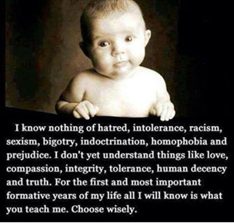
Resources to Support Your Work
Camille Catlett
camille.catlett@unc.edu

This handout is available to download at
http://fpg.unc.edu/presentations/resources-support-your-work-2

Core Resources for Faculty
- Pennsylvania Core Knowledge Competencies for Early Childhood and School Age Professionals http://www.pakeys.org/uploadedContent/Docs/CKC%20and%20Big%20Ideas%20Framework/36124_Competencies_.pdf
- Pennsylvania Infant, Toddler, and PreKindergarten Standards for Early Childhood http://www.education.pa.gov/Early%20Learning/Early%20Learning%20Standards/Pages/Infant-Toddler-Pre-K-Learning-Standards.aspx#.VhvwlyuK92A
- SCRIPT-NC Resources http://scriptnc.fpg.unc.edu/resource-search

Developmentally Appropriate Practice

NAEYC. (2009). Developmentally appropriate practice in early childhood programs serving children from birth through age 8. https://www.naeyc.org/files/naeyc/file/positions/PSDAP.pdf

What is known about child development and learning—referring to knowledge of age-related characteristics that permits general predictions about what experiences are likely to best promote children’s learning and development

What is known about the social and cultural contexts in which children live— referring to the values, expectations, and behavioral and linguistic conventions that shape children’s lives at home and in their communities that practitioners must strive to understand in order to ensure that learning experiences in the program or school are meaningful, relevant, and respectful for each child and family

What is known about each child as an individual—referring to what practitioners learn about each child that has implications for how best to adapt and be responsive to that individual variation

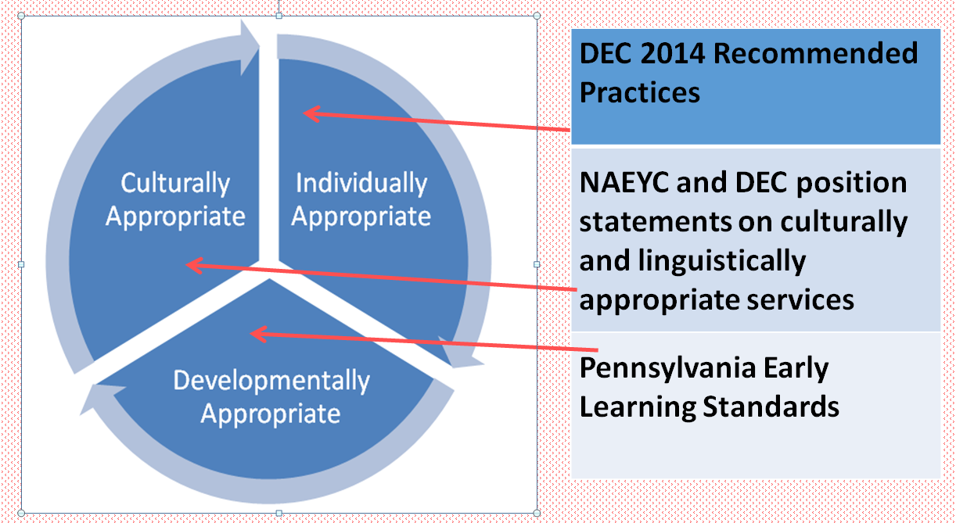
Core Knowledge Competence Areas

Child Growth and Development

SCRIPT-NC Resources: http://scriptnc.fpg.unc.edu/child-development-conception-through-age-8

Resource List: http://scriptnc.fpg.unc.edu/resources/resource-handout-child-development-conception-through-age-8

The Changing Face of the United States: The Influence of Culture on Early Child Development
http://main.zerotothree.org/site/DocServer/Culture_book.pdf?docID=6921
Published by ZERO TO THREE, this resource looks at how culture can be defined and provides an overview of the research showing how culture affects child development in the following areas: cognitive development, language development (of mono- and bilingual infants and toddlers), and socioemotional development. Summary tables of each area are provided.

Pathways Awareness Foundation Motor Development Videos https://www.youtube.com/user/PathwaysAwareness/videos
If you’re looking for excellent video footage that shows what development looks like for children who are typically developing and those who aren’t, these are a great instructional resource.

Raising Boys and Girls: Differences in Physical Development
http://www.babycenter.com/0_raising-boys-and-girls-differences-in-physical-development_3659011.bc
This short article presents a brief description of the gender differences in physical development.

Supporting the Oral Language Development of Young Dual Language Learners http://www.youtube.com/watch?v=5HD2wydP0mE
In this webinar, Dr. Linda Espinosa presents an overview of current research findings on oral language development in young dual language learners and provides strategies to enhance their language proficiency. The webinar concludes with a Q&A session.

Featured Film:
Korean-English exchange https://www.facebook.com/WildBunchRadio/videos/390722991048473/?fref=nf

Curriculum and Learning Experiences

Resource Lists:
- Creative Activities Landing Pad Handout http://fpg.unc.edu/presentations/recipes-success
- Play is the Heart of Development http://fpg.unc.edu/presentations/recipes-success
- Social-emotional Development Resources http://scriptnc.fpg.unc.edu/resources/child-guidance-resources

Creating Teaching Tools for Young Children with Challenging Behavior
http://www.challengingbehavior.org/do/resources/teaching_tools/ttyc.htm
Free tools developed by TACSEI and based on evidence-based practices can be downloaded from this website. Teaching Tools contains strategies to help teachers support young children with challenging behavior. Included are handouts and worksheets, as well as helpful techniques and strategies.

Crisis in the Kindergarten: Why Children Need to Play in School
http://www.allianceforchildhood.org/sites/allianceforchildhood.org/files/file/kindergarten_report.pdf
This 2009 publication from Alliance for Childhood highlights evidence of changes in the amount of child-initiated play that occurs in kindergarten classrooms and offers both data and arguments for the importance of restoring that kind of activity.

Engaging Diverse Learners Through the Provision of STEM Education Opportunities http://secc.sedl.org/resources/briefs/diverse_learners_STEM/

This briefing paper highlights a variety of methods and materials for supporting an increased understanding of and emphasis on STEM.

Help! They Still Don’t Understand Counting http://files.eric.ed.gov/fulltext/EJ875422.pdf
This article describes a developmental framework for counting and how it can weave in with long-established best practices for supporting young children with and without disabilities. The article briefly discusses how difficulty with counting may or may not be indicative of a math disability.

Let's Play! Assistive Technology Interventions for Play http://yec.sagepub.com/content/5/2/19.full.pdf+html
Lane and Mistrett’s 2002 article discusses how assistive technology can be used in play to support the needs of children with disabilities and their families.

Moving Bodies, Building Minds: Foster Preschoolers’ Critical Thinking and Problem Solving Through Movement http://www.naeyc.org/files/yc/file/201109/Moving%20Bodies_Russo_Marigliano_Online_0911.pdf
This article explains how critical thinking and problem-solving skills can be developed in preschoolers through movement. It also offers strategies for executing these movement activities and considerations for children with special needs and their families.

Play’s Potential in Early Literacy Development
http://www.child-encyclopedia.com/pages/PDF/Christie-RoskosANGxp.pdf
This article by Christie and Roskos summarizes what we currently know about two basic relationships: 1) the relationship between play processes (language, pretense, narrative development) and early literacy skills; and 2) relationships between the play environment – both physical and social – and early literacy activity and skills.

Featured Films:
- A Creative Adventure http://eclkc.ohs.acf.hhs.gov/hslc/tta-system/teaching/eecd/Domains%20of%20Child%20Development/Creative%20Arts/ACreativeAdvent.htm
- Three Generations Talk About Play https://www.youtube.com/watch?v=is5W6GxAI3c
- Neil deGrasse Tyson: Get Out Of Their Way http://www.youtube.com/watch?v=AIEJjpVlZu0&feature=youtu.be
- Technology will never replace love https://www.youtube.com/watch?v=Kiq_TrEdbl4

Families, Schools and Community Collaboration and Partnerships

Resource List: http://scriptnc.fpg.unc.edu/resources/child-family-and-community-landing-pad

SCRIPT-NC Resources: http://scriptnc.fpg.unc.edu/child-family-and-community

Two More Evidence-Based Lenses
- Pennsylvania Standards: Partnerships for Learning – Families, Early Care and Education Programs, and Communities
https://www.pakeys.org/uploadedContent/Docs/Career%20Development/2014%20Pennsylvania%20Learning%20Standards%20for%20Early%20Childhood%20Infants%20Toddlers.pdf

- DEC Recommended Practices: Family
PDF document http://www.dec-sped.org/recommendedpractices
Early Childhood Technical Assistance Center RP Resources http://ectacenter.org/decrp/

CONNECT Module 3: Communication for Collaboration
http://community.fpg.unc.edu/connect-modules/learners/module-3
This module describes effective communication practices for professional and families in early education and intervention. Information on research findings and related policies are provided as well as examples of embedded interventions. Included in the module are suggestions for activities, handouts, video and audio clips.

CONNECT Module 4: Family-Professional Partnerships
http://community.fpg.unc.edu/connect-modules/learners/module-4
This module presents effective practices for developing family-professional partnerships in a process of developing rapport, forming shared decisions, and partnering with the family to address challenges. Information on research findings and related policies are provided as well as examples of embedded interventions. Included in the module are suggestions for activities, handouts, video and audio clips.

Supporting Families of Children with Disabilities in Inclusive Programs
http://www.naeyc.org/files/yc/file/200601/KaczmarekBTJ.pdf
Louise Kaczmarek’s article presents ways in which inclusive early childhood intervention programs can best support children with disabilities and their families. These include coordinated planning, establishing ongoing communication, and helping families to access community resources. Three tables on each section are presented, outlining the advantages and challenges involved, as well as suggestions for addressing the challenges.

What Early Childhood Educators Need to Know: Developing Effective Programs for Linguistically and Culturally Diverse Children and Families http://www.naeyc.org/files/tyc/file/WhatECENeedToKnow.pdf
This paper discusses issues commonly faced by second-language learners. It also describes the process of second-language acquisition, and provides ways in which this learning can be supported in the classroom and with parents.

Featured Film:
Think before you judge a family http://www.huffingtonpost.com/2014/02/24/think-twice-before-judge-another-parent_n_4826485.html?ncid=fcbklnkushpmg00000037

Assessment

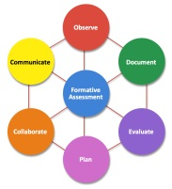
Formative Assessment Resources http://scriptnc.fpg.unc.edu/formative-assessment
- Handouts
- PowerPoint slides

Activities and Assignments for Using Formative Assessment in Early Childhood Courses
- Introduction to Early Childhood Education http://scriptnc.fpg.unc.edu/resources/ideas-and-strategies-incorporating-formative-assessment-introduction-early-childhood-educa
- Child Development http://scriptnc.fpg.unc.edu/resources/ideas-and-strategies-incorporating-formative-assessment-child-development-conception-age-8
- Child, Family and Community http://scriptnc.fpg.unc.edu/resources/child-family-and-community-ideas-and-strategies-incorporating-formative-assessment
- Health, Safety, and Nutrition http://scriptnc.fpg.unc.edu/resources/ideas-and-strategies-incorporating-formative-assessment-health-safety-and-nutrition
- Infants, Toddlers, and Twos http://scriptnc.fpg.unc.edu/resources/ideas-and-strategies-incorporating-formative-assessment-infants-toddlers-and-twos
- Language and Literacy http://scriptnc.fpg.unc.edu/resources/language-and-literacy-formative-assessment
- Social-Emotional Development/Child Guidance http://scriptnc.fpg.unc.edu/resources/social-emotional-development-child-guidance-formative-assessment

Communication

SCRIPT-NC Resources: http://scriptnc.fpg.unc.edu/language-and-literacy
Resource List: http://scriptnc.fpg.unc.edu/resources/language-literacy-handout

Adapting Literacy Learning Practices for Young Children with Disabilities (PowerPoint presentation)
http://www.earlyliteracylearning.org/ppts/OSEP_National_EC_Conf_Dec_08.pps
Developed by the CELL, this presentation provides suggestions for literacy activities for young children with disabilities that educators and parents can use.

Center for Early Literacy Learning (CELL) http://www.earlyliteracylearning.org/
The goal of the Center for Early Literacy Learning (CELL) is to promote the adoption and use of evidence-based early literacy learning practices. The website has downloadable practice manuals, including manuals that address adaptations for children of diverse abilities, video clips, family resources, and other materials.

The Early Catastrophe: The 30 Million Word Gap by Age 3
https://www.aft.org/pdfs/americaneducator/spring2003/TheEarlyCatastrophe.pdf
This article presents the findings from a longitudinal study, which sought to understand what aspects of a child’s early experience could account for the differences in rates of vocabulary growth among 4-year-olds. The study concluded by highlighting the importance of the early years’ experience in all aspects of the child’s development.

Phonological Awareness is Child’s Play! http://www.naeyc.org/files/yc/file/200901/BTJPhonologicalAwareness.pdf
This paper explains the importance of phonological awareness in reading development and describes useful and practical ways in which teachers can support children’s phonological awareness development. Attention is paid to how English and Spanish phonemes vary, and the implications for supporting each young reader.

Storybook Reading for Young Dual Language Learners
http://www.naeyc.org/files/yc/file/201101/GillandersOnline0111.pdf
This article explains the importance of storybook reading for dual language learners and offers strategies for implementing these in the classroom. An example of a storybook reading lesson plan is provided at the end.

Supporting Parent and Caregiver Involvement in Early Literacy Practices with Young Children from Diverse Backgrounds and Abilities http://depts.washington.edu/hscenter/sites/default/files/01_15m_inclusion_inservice/08_family_
literacy/documents/family_literacy_research_brief.pdf
This research brief presents a review of six studies on early literacy practices that support parent involvement. Three of these studies are intervention studies, which are briefly summarized in a table at the end of the paper. Implications for practice are discussed.

Featured Film: Catch a bubble https://www.youtube.com/watch?v=n2dLPFaehV0&feature=em-share_video_user

Health, Safety and Nutrition
Resource List: http://scriptnc.fpg.unc.edu/edu-153-health-safety-and-nutrition-0
SCRIPT-NC Resources: http://scriptnc.fpg.unc.edu/edu-153-health-safety-and-nutrition-0
Henry Gets Around http://www2.cde.state.co.us/media/resultsmatter/RMSeries/HenryGetsAround.asp
This clip shows how a child with physical disabilities is able to participate fully in all the activities inside and outside the classroom. He walks, runs, climbs and jumps while being supported by his ankle-foot orthosis and sometimes gets around by using a wheelchair.

Natural Environments: A Letter From a Mother to Friends, Families, and Professionals http://yec.sagepub.com/content/5/3/21.full.pdf+html
Written by a mother of a boy with Down syndrome, this article from Young Exceptional Children describes how the family made use of routines and activities in their natural environments to support their child’s development.

Promoting the Health, Safety and Well-Being of Young Children with Disabilities and Developmental Delays
http://dec.membershipsoftware.org/files/Position%20Statement%20and%20Papers/Health%20Position%20Statement.pdf
This 2013 position statement from the Division for Early Childhood elaborates on the six recommendations presented by the DEC, explaining the rationale behind these recommendations and presenting the research evidence supporting the recommendations.

Featured Film:
Like a Girl https://www.youtube.com/watch?v=XjJQBjWYDTs

Individually Appropriate Practices

Resource List: http://scriptnc.fpg.unc.edu/children-exceptionalities

DEC/NAEYC. (2009). Early childhood inclusion. Chapel Hill: UNC, FPG Child Development Institute. http://npdci.fpg.unc.edu/resources/articles/Early_Childhood_Inclusion

Early childhood inclusion embodies the values, policies, and practices that support the right of every infant and young child and his or her family, regardless of ability, to participate in a broad range of activities and contexts as full members of families, communities, and society. The desired results of inclusive experiences for children with and without disabilities and their families include a sense of belonging and membership, positive social relationships and friendships, and development and learning to reach their full potential. The defining features of inclusion that can be used to identify high quality early childhood programs and services are access, participation, and supports.

US Department of Health and Human Services/US Department of Education. (2015, September). Policy statement on inclusion of children with disabilities in early childhood programs.
http://www2.ed.gov/about/inits/ed/earlylearning/inclusion/index.html

Inclusion in early childhood programs refers to including children with disabilities in early childhood programs, together with their peers without disabilities; holding high expectations and intentionally promoting participation in all learning and social activities, facilitated by individualized accommodations; and using evidence-based services and supports to foster their development (cognitive, language, communication, physical, behavioral, and social-emotional), friendships with peers, and sense of belonging. This applies to all young children with disabilities, from those with the mildest disabilities, to those with the most significant disabilities.

Division for Early Childhood. (2014). DEC recommended practices in early intervention/early childhood special education. http://dec.membershipsoftware.org/files/Recommended%20Practices/DEC_RPs_%204-25-14.pdf

Recommended Practices Resources http://ectacenter.org/decrp/
→Interaction Resources http://ectacenter.org/decrp/topic-interaction.asp

Performance Checklists http://ectacenter.org/decrp/type-checklists.asp

→Interaction Checklists http://ectacenter.org/decrp/type-checklists.asp

→Adult-Child Interaction Checklist http://ectacenter.org/~pdfs/decrp/INT-1_Adult-Child_Interaction.pdf

Illustrations http://ectacenter.org/decrp/type-illustrations.asp

Practice Guides for Practitioners http://ectacenter.org/decrp/type-pgpractitioner.asp

→Interaction Practice Guide for Practitioners: Peer Interaction http://ectacenter.org/~pdfs/decrp/ECTAprac_PeerInteraction_PRACT_print.pdf

Practice Guides for Families http://ectacenter.org/decrp/type-pgfamily.asp

→Interaction Practice Guide for Practitioners: Peer Interaction http://ectacenter.org/~pdfs/decrp/ECTAprac_PeerInteraction_PARENT_print.pdf

Do You See the Recommended Practices?

Recommended Practice for Interaction | Observed?

INT1. Practitioners promote the child’s social-emotional development by observing, interpreting, and responding contingently to the range of the child’s emotional expressions.

INT 2. Practitioners promote the child’s social development by encouraging the child to initiate or sustain positive interactions with other children and adults during routines and activities through modeling, teaching, feedback, and/or other types of guided support.

INT3. Practitioners promote the child’s communication development by observing, interpreting, responding contingently, and providing natural consequences for the child’s verbal and non-verbal communication and by using language to label and expand on the child’s requests, needs, preferences, or interests.

INT4. Practitioners promote the child’s cognitive development by observing, interpreting, and responding intentionally to the child’s exploration, play, and social activity by joining in and expanding on the child’s focus, actions, or intent.

INT5. Practitioners promote the child’s problem-solving behavior by observing, interpreting, and scaffolding in response to the child’s growing level of autonomy and self-regulation.

Resources for Montgomery County Community College Courses

Infant and Toddler Development http://scriptnc.fpg.unc.edu/infants-toddlers-and-twos

Teaching with Technology http://scriptnc.fpg.unc.edu/educational-technology

Introduction to Education/Introduction to Early Childhood Education
http://scriptnc.fpg.unc.edu/introduction-early-childhood-education-0

Working with Students with Special Needs http://scriptnc.fpg.unc.edu/children-exceptionalities

Guiding Children’s Reading Development/Literature in Early Childhood and Elementary Education http://scriptnc.fpg.unc.edu/language-and-literacy

Art for Young Children http://scriptnc.fpg.unc.edu/creative-activities

Teaching Mathematics to Young Children/Teaching Science Preschool/Elementary http://fpg.unc.edu/presentations/resources-support-your-work-2

Connecting Families, Schools, and Communities http://scriptnc.fpg.unc.edu/child-family-and-community

Child Care Practicum/Student Teaching http://scriptnc.fpg.unc.edu/early-childhood-capstone-practica

Teaching English Language Learners http://fpg.unc.edu/presentations/resources-support-your-work-2

Finding Free Films
- CONNECT Modules http://community.fpg.unc.edu/connect-modules/
- Illustrations of DEC Recommended Practices http://ectacenter.org/decrp/type-illustrations.asp
- Desired Results Access Project Video Library http://www.draccess.org/videolibrary/
- Results Matter Video Library http://www.cde.state.co.us/resultsmatter/rmvideoseries
  - Catalog http://www.cde.state.co.us/resultsmatter/rmvideolibrarycatalog
- University of Northern Iowa Empowering Preschool Quality
  - http://www.uni.edu/coe/regentsctr/epq/search (to view clips online)
  - http://www.uni.edu/coe/regentsctr/epq/content/dvd-order-form (to order DVDs for $10)
- Video Library http://www.ecetp.pdp.albany.edu/videolibrary.shtm

Closing Clip

A Letter to a Teacher http://www.youtube.com/watch?v=z-yuQKi-bdo

